The blue point of submitting PR both on Github and Gitee

- Background
This file wants to describe how to keep Gitee as the main repository and also support working on Github. It mainly introduces the process of submitting the PR.

- The process of merging commits into repo when working both on Gitee and Github
- Initial status
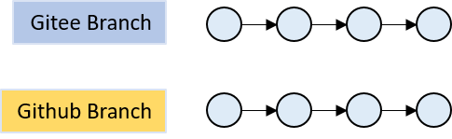
At present, all commits are same for basic branch both on Gitee and Github.
- Two developers work on Gitee and Github separately
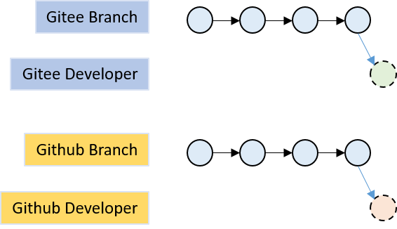
Suppose that the two new commits are not conflict between them.
- The process of merging commit
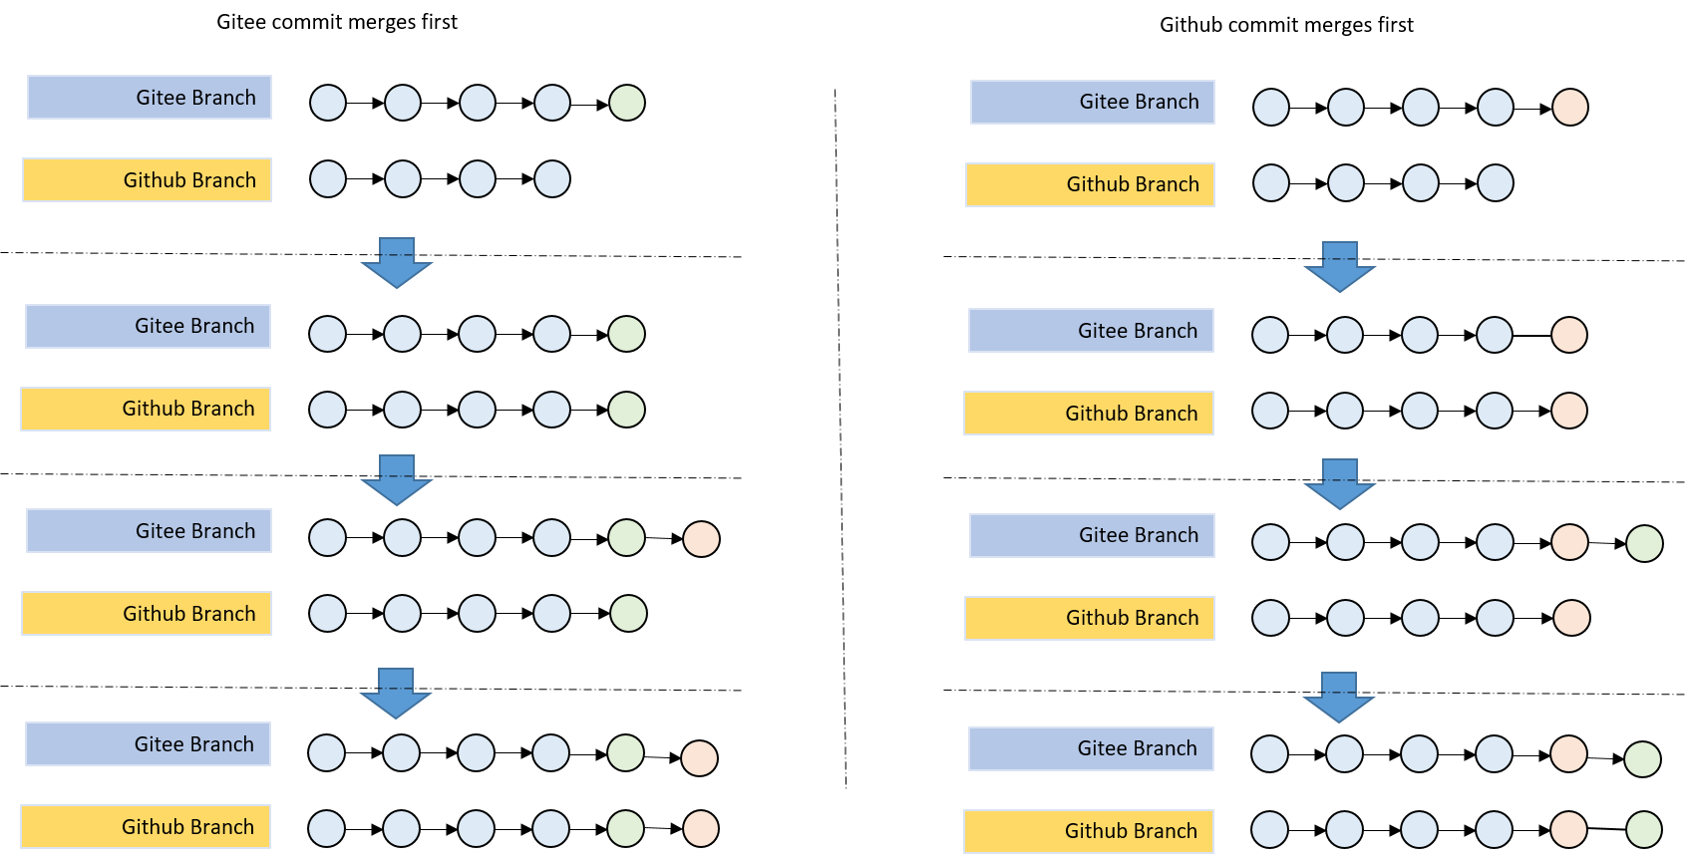

- Submit PR on Github
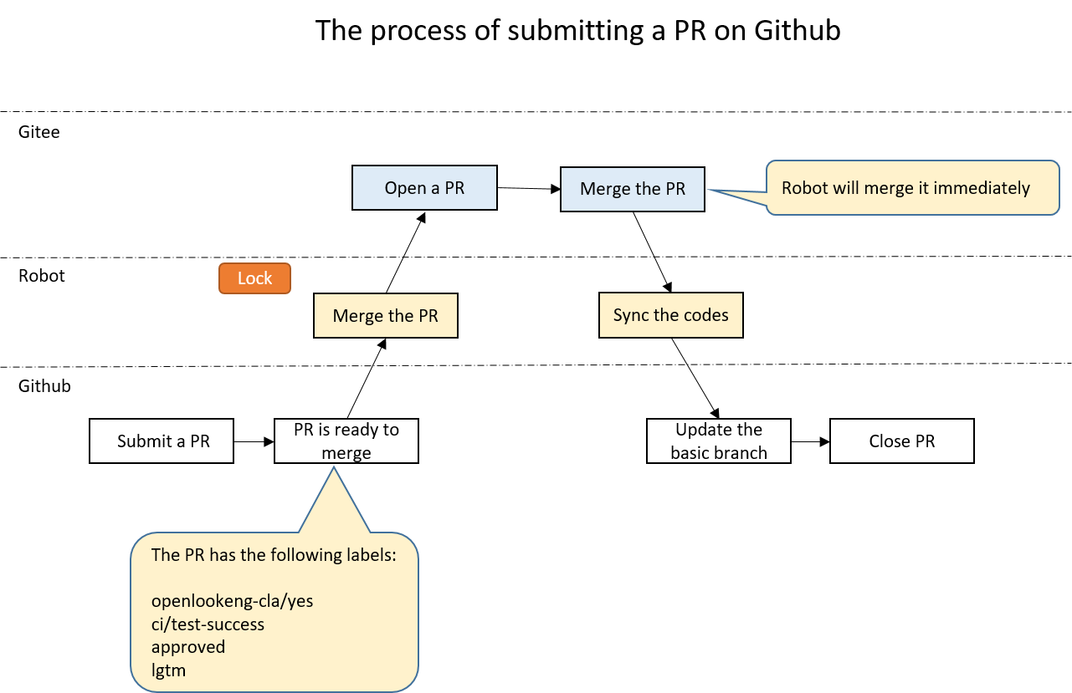

- A developer submits a PR on Github. Reviewers review it and trigger the test until it is ready to be merged.

- Robot watches the PR and merges it when it is ready.
  - It adds a lock first.
  - Second, it opens a new PR on Gitee, synchronizes the codes from Github and merges it immediately.
  - Third, it synchronizes the codes merged back to the Github to update the basic branch of repo in order to keep it same with Gitee.
  - Forth, it closes the PR on Github and leaves a comment to tell the developer that the PR is merged.
  - Last, it unlocks.

- Submit PR on Gitee
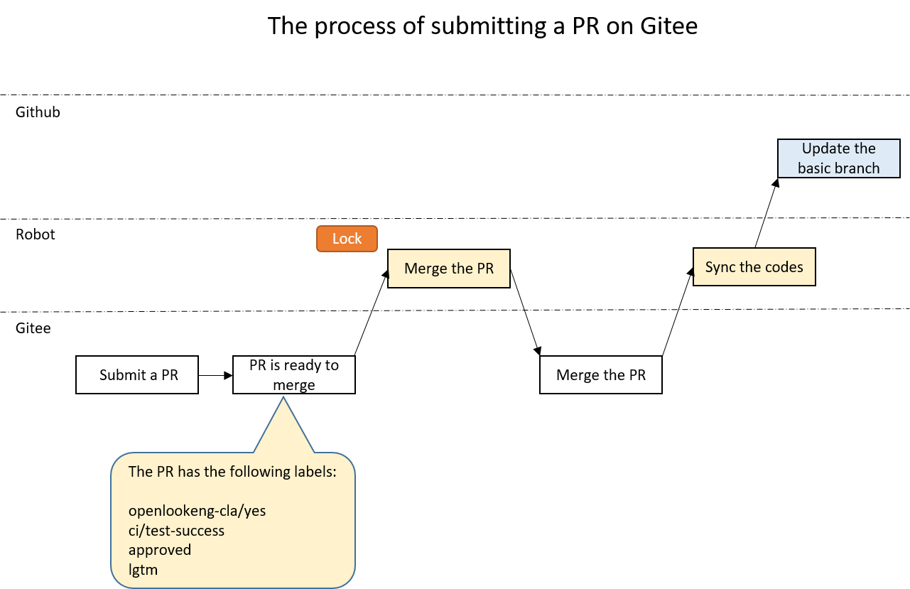

- A developer submits a PR on Gitee. Reviewers review it and trigger the test until it is ready to be merged.

- Robot watches the PR and merges it when it is ready.
- It adds a lock first.
- Second, It merges the PR immediately.
- Third, it will synchronize the codes merged back to the Github to update the basic branch of repo in order to keep it same with Gitee.
- Last, it unlocks.

